Anyone can learn LabVIEW Anywhere 😊

Tutor Instructions

Open VM
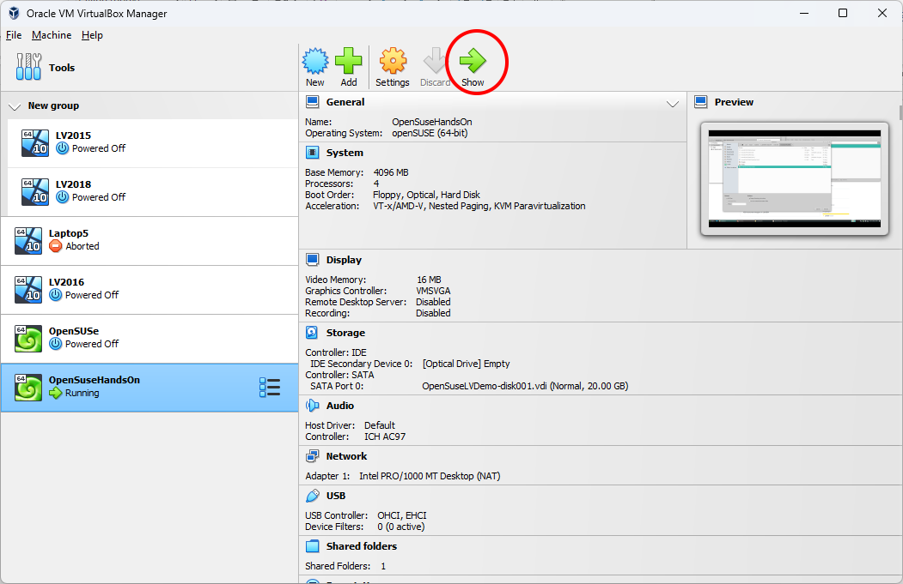

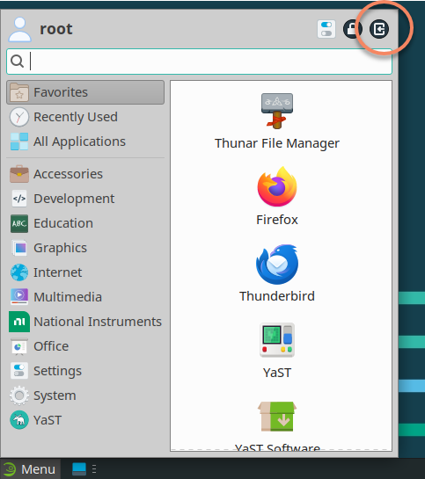

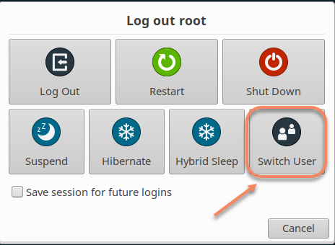

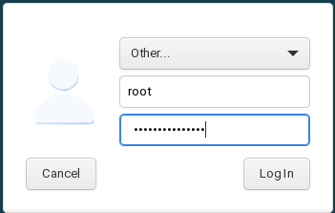
Login as root, this solves a lot of issues with LabVIEW and Linux. Password is the same as the normal login.
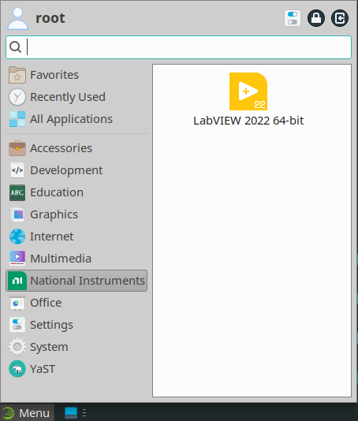
Load LabVIEW
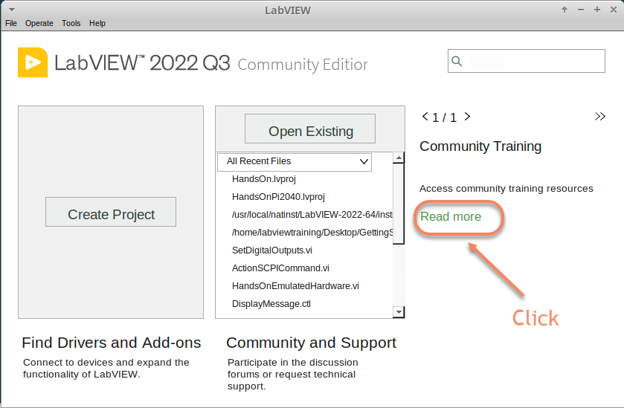
We’ve modified the Getting Started Window, this link will take you to the CTI Github repo.

/usr/local/natinst/LabVIEW-2022-64/instr.lib/HandsOnPi2040/cti-drivers-lv-visa-main

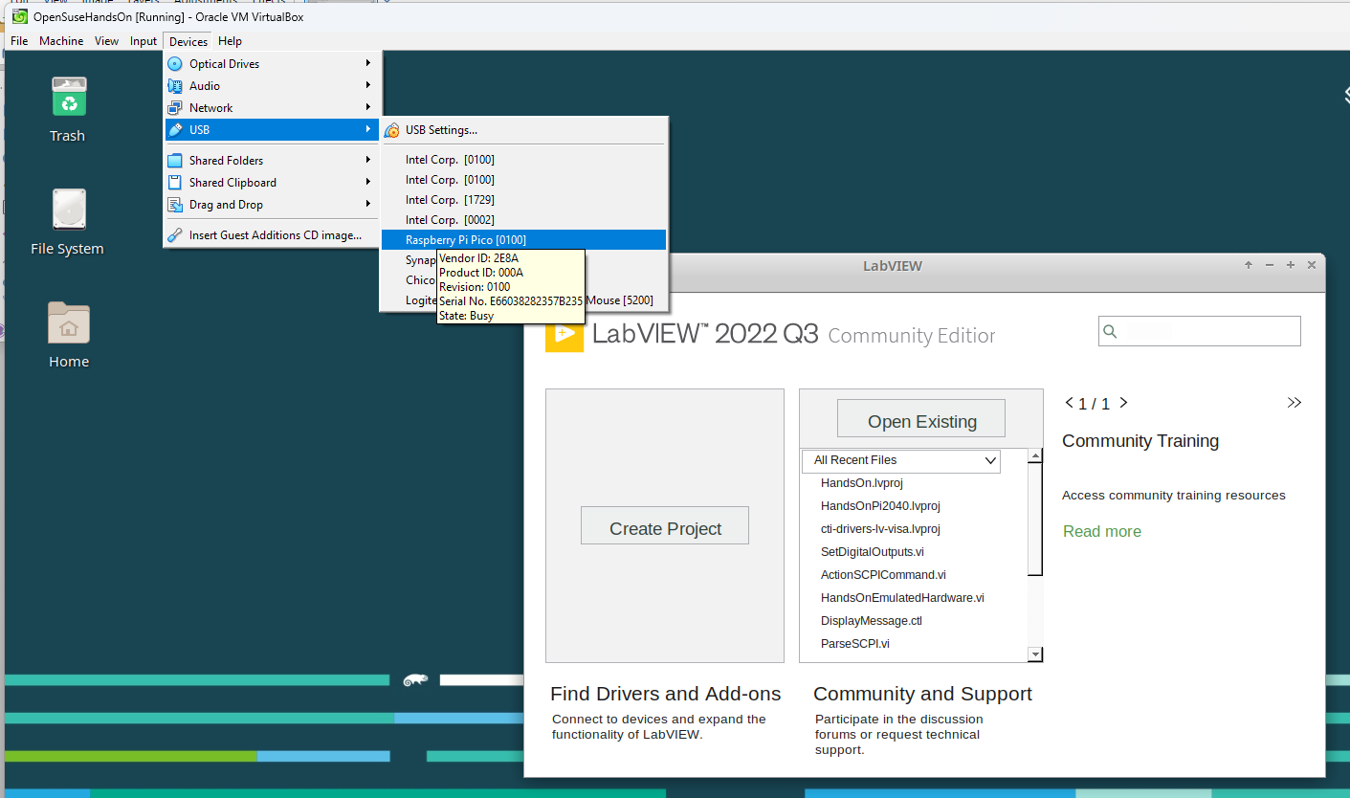
Connect the Pico

Hardware
Raspberry Pi Pico or Pico W.
USA and UK Suppliers - We're probably going to standardise on Pico-W
https://www.pishop.us/product/pico-breadboard-kit/
https://thepihut.com/products/analog-test-board
https://www.waveshare.com/analog-test-board.htm
https://thepihut.com/products/breadboard-kit-for-raspberry-pi-pico

